**ROLE PLAY TECHNIQUE TO IMPROVE SPEAKING ABILITY AT SMA NEGERI 1 KAYAN HULU**

**ARTICLE**

**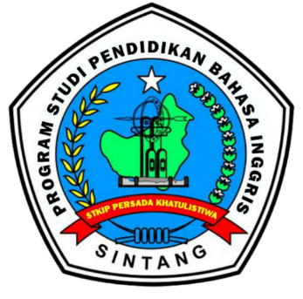**

**WRITTEN BY:**

**YUNETTY LUSIANA SINAGA**

Student Id 200407145

**STKIP PERSADA KHATULISTIWA**

**ENGLISH LANGUAGE EDUCATION STUDY PROGRAM**

**SINTANG**

**2024**

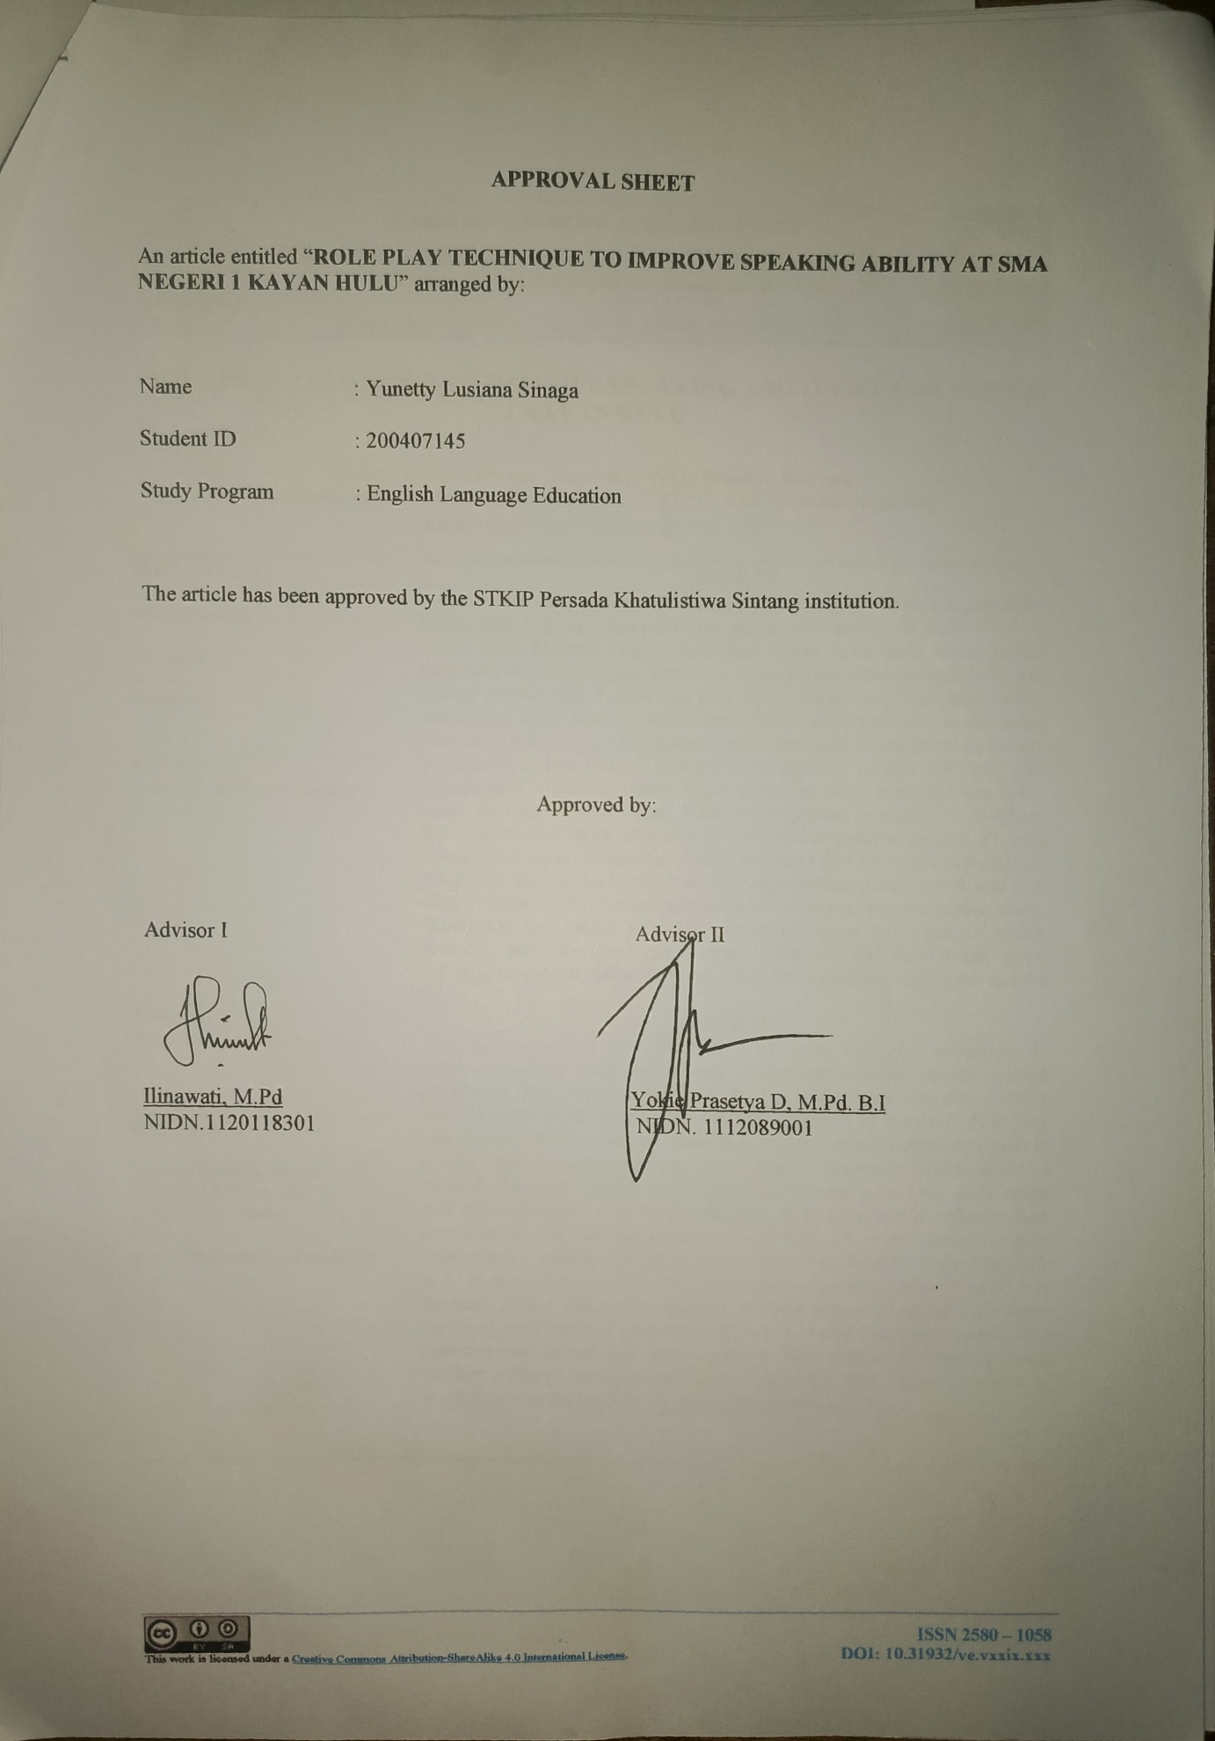

|  |  |  |
| --- | --- | --- |
| D:\LOGO STKIP PERSADA.png | Akreditasi KEMENRISTEKDIKTI, Nomor: 148/M/KPT/2020  VOX EDUKASI: Jurnal Ilmiah Ilmu Pendidikan  Volume 13 Nomor 2, Nopember 2022, Halaman xx – xx  <http://jurnal.stkippersada.ac.id/jurnal/index.php/VOX> | D:\Vol 11 no 1 Vox Edisi April 2020\cover_VOX_EDUKASI_11_1.jpg |

**ROLE PLAY TECHNIQUE TO IMPROVE SPEAKING ABILITY AT SMA NEGERI 1 KAYAN HULU**

**Yunetty Lusiana Sinaga1, Ilinawati2,** **Yokie Prasetya Dharma3.**

*1 English Language Education Study Program, STKIP Persada Khatulistiwa Sintang*

*Email:* *yunettylusi*[*anasinaga@gmail.com1*](mailto:anasinaga@gmail.com1)

|  |  |  |
| --- | --- | --- |
| **INFO ARTIKEL** |  | **ABSTRAK** |
| ***Riwayat Artikel:***  Menerima :  Revisi :  Diterima : |  | Penelitian ini mengevaluasi efektivitas teknik role play dalam meningkatkan kemampuan berbicara dan partisipasi siswa kelas sebelas di SMA Negeri 1 Kayan Hulu. Masalah yang diidentifikasi adalah siswa perlu meningkatkan partisipasi dan kemampuan berbicara siswa karena siswa merasa malu dan kurang percaya diri. Teknik role play dipilih karena kemampuannya untuk melibatkan siswa dalam simulasi komunikasi yang mendekati situasi nyata. Metode penelitian yang digunakan adalah penelitian tindakan kelas, dengan pengumpulan data melalui observasi, wawancara, catatan lapangan, dan dokumentasi. Hipotesis bahwa teknik role play akan meningkatkan kedua aspek tersebut terbukti benar. Hasil menunjukkan peningkatan signifikan dalam partisipasi siswa, dari skor 69 pada siklus pertama menjadi 81 pada siklus kedua, serta peningkatan kinerja berbicara dari 54 pada siklus pertama menjadi 80 pada siklus kedua. Peneliti menyimpulkan bahwa teknik role play efektif dalam meningkatkan kemampuan berbicara dan partisipasi siswa. Disarankan agar teknik role play diterapkan secara rutin, dengan variasi skenario, pelatihan untuk guru, evaluasi berkala, dan keterlibatan siswa dalam perancangan skenario, untuk terus meningkatkan efektivitas metode ini. |
| ***Kata Kunci:*** |  |
| *Role Play, Berbicara, Mengajar* |  |
| ***Keywords:*** |  | ***ABSTRACT*** |
| *Role Play, Speaking, Teaching* |  | *This research examines the effectiveness of using role play techniques to improve speaking skills and increase student participation among eleventh graders at SMA Negeri 1 Kayan Hulu. The initial issue was that students were hesitant to participate and lacked confidence in speaking. Role play was chosen because it allows students to practice real-life communication in a safe and engaging environment. Using a classroom action research method, data were gathered through observations, interviews, field notes, and documentation. The hypothesis that role play would enhance both participation and speaking skills was confirmed. The results showed a clear improvement, with participation scores increasing from 69 in the first cycle to 81 in the second, and speaking performance improving from 54 to 80 over the same period. The research concludes that role play is an effective technique for developing students' speaking skills and boosting their participation. It is recommended to use role play regularly with diverse scenarios, provide teacher training, conduct periodic evaluations, and involve students in creating scenarios to make the method even more effective.* |
| ***Korespondensi:***  **Yunetty Lusiana Sinaga**  *Afiliasi STKIP Persada Khatulistiwa Sintang*  *Email:*  *yunettylusianasinaga@gmail.com* |
|  |  |  |

# INTRODUCTION

English is known as an international language and is used as a second language in many countries because of its wide use in global fields such as business, technology, science, education, and entertainment. As an international language, English helps people from different communities around the world to exchange culture, information, and ideas. In Indonesia, English is considered a foreign language, but it is still very important for everyone to learn. English plays a big role in both education and other areas. In schools, English is a compulsory subject that students learn from elementary school to university, following the curriculum set by the Ministry of Education and Culture. Many parents also encourage their children to improve their English skills because speaking English is a key way to communicate.

Speaking was an action in which words helped to express ideas and information to a listener. Speaking was a natural behaviour that society frequently participated in. People were always doing things to communicate with others. This was the most important way for a speaker to express himself by language; speaking was a type of communication that took place in face-to-face interactions and was a component of conversation. Speaking includes not just the production of sounds but also the use of gestures and motions. (Saldaria & Cahyani, 2019; p.20) one type of oral communication is speaking, which involves using spoken language or a spoken tool to express information. Highlighted a core concept of effective communication.

Speaking was our way of conveying our thoughts, our feelings, our opinions, and others. Speaking was expressing what the speaker wanted to say or talk about, then the listener processed what the speaker meant. Speaking attempts to give conversation a voice, highlighting and giving it the respect it deserves (Grugeon et al, 2012;p.1). Speaking is one of the four skills, namely: speaking, grammar, vocabulary, writing. Speaking is an activity in which we produce speech in the form of words and sentences orally to communicate with others.

Speaking is an important way of communication. People use almost constantly. Speaking is an important ability in English language learning as it is used for communication. Communication is a characteristic of human society (Akhter et al 2020; p.6027). As humans who live side by side and carry out social activities we need to express our thoughts, opinions, and feelings to interact in social life. Communication is the process of sending and receiving messages between individuals or groups, which includes the exchange of information, ideas, thoughts, feelings, or opinions. (Cherry, 1956 ;p. 6) Communication is exchanging habits and patterns of life based on established rules. Speaking is essential as a productive skill.

One of the greatest times for teaching students to talk is during English class. By participating in various kinds of delightful, easy-to-understand exercises that might help students improve their ability to speak. Role play is one activity that will be used to help students improve their ability to speak. (Rao as cited in Hussain 2017;p.15) stated Speech provides a great introduction to other language learning abilities. Speaking is a natural approach to learn foreign languages. Speaking is an important part of language learning.

The main purpose of speaking skills is to build effective communication, facilitate social interaction, and convey messages clearly and precisely to listeners. (Nunan cited in Bahrani and Soltani 2012;p. 25) stated that Success in language acquisition is measured by the ability for speaking in the target language. That is, the instructor must be able to understand the learning content in order to improve students' abilities, particularly in speaking, so that the aim may be achieved.

When communicating in English, individuals should pay attention to key language components, such as pronunciation, vocabulary, grammar, fluency, and comprehension (Cameron cited in Adelita & Daulay 2023).Improving the abilities of students in these five areas requires both theoretical knowledge and practical work.

1. Pronunciation

Pronunciation is an essential component of effective communication, and it applies to many aspects of personal and professional life. Teaching pronunciation not only makes students aware of different sounds and sound aspects and what they mean, but it may greatly improve their speaking (Harmer 2001;p. 183). The speaker must be able to pronounce the words and produce physical sounds that convey meaning.

1. Grammar

Grammar is an essential component of language that contributes significantly to efficient communication. Theoretical linguists typically view grammar as an abstract technique that differentiates sentences from non-sentences in a language (Kay 1979; p.142). Grammatical is highly crucial in speaking because if the speaker does not grasp the grammatical structure, he cannot speak English correctly.

1. Vocabulary

A rich vocabulary is a must for efficient communication and has an important effect on personal, intellectual, and professional achievement. Vocabulary In general, vocabulary refers to the understanding of word meanings (Hiebert & Kamil 2005;p.2). Our limited vocabulary makes it difficult to communicate.

1. Fluency

Fluency is frequently described as being able to express oneself in a language with ease, flexibility, and proficiency. Fluency, or the ease or difficulty of processing information, is a key metacognitive signal for thinking (Oppenheimer 2008; p. 237). When speaking effectively, students should be able to understand the point or message.

1. Comprehension

Comprehension is the ability to grasp and interpret information, whether spoken, written, or visual. It means making sense of the text, extracting meaning, and understanding the underlying concepts or ideas. Comprehension is an essential component of efficient communication and learning in a variety of settings.

Role play is a useful tool for improving English speaking skills by allowing students to practice communication in various real-life situations. Through role play, we can prepare students for conversation in any context (Ladousse 1987; p.6). Role play allows students a simulated environment in which they may actively participate in discussions, use language skills, and practise communication in a variety of situations.

Role playing is a social or educational activity in which participants imitate certain roles and act out certain scenarios or situations. In the role play the individual plays a character identity or role that is different from himself. Role playing can be used in a variety of contexts, including education, theater, training, etc. This allows participants to engage more actively in the thinking and actions of their assigned roles. (Tompkins 1998;p. 1) defines role play: This classroom teaching technique encourages students to take an active part in learning English. The theory highlights role play as a teaching strategy which promotes active participation by students in the English learning process. Based on (Deneeve & Heppner 1997; p. 234) Role Play simulations consist of students playing specific roles in a group. Role play simulations can make learning more dynamic and interactive, helping students to retain information more effectively and apply it in real-world situations.

Role play is frequently used as a method of active learning because it immediately involves participants, allowing them to learn using direct experience rather than only listening or reading. (Hattings cited in Purnamawati et al 2015; p. 2) stated role play is a creative way for students to practice and improve their English communication skills, it simulates discussion environment. Furthermore, it permits students to be creative and quickly take on the role of another individual.

**RESEARCH METHOD**

Research design is a systematic framework or plan for planning and carrying out research. The research design involves method selection and data collecting strategies. Research design assists researchers in organising their ideas and describes the operational specifics of the research.

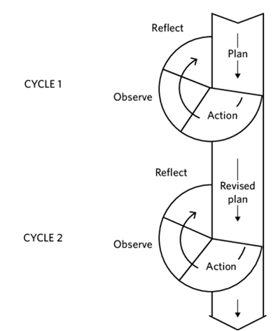

Figure 1. Classroom Action Research Cycle

Adapted from Kemmis & McTaggart in Burns (2010; p.9)

The researcher uses Classroom Action Research (CAR) that contained of four stages, they are: Planning, Action, Observation, Evaluation or Reflection. (Based on Efron and Ravid 2013, p. 2) stated the terms action research are frequently used synonymously in the field of education since they both highlight the importance of practitioners in carrying out investigations in classrooms and schools. Cooperative action research has the potential to benefit workers while also improving services, circumstances, and functions in the situation. Based on the above statement, we can infer that Classroom Action Research is used in education to enhance the quality of instructors, administrators, students, the teaching-learning process, and specific community workers.

Furthermore, it produces better results when done collaboratively. Teachers do action research in their classrooms or schools by designing a research based on their area of interest (O’Connor 2006; p. 3). To begin the CAR process, researchers or teachers must identify and study problems in a specific context. (Burns 2022; p.992), defined Action research combines action and research into one. Classroom action research works to enhance practice by evaluation and reflection.

Researcher choose CAR based on the problems that exist at SMA Negeri 1 Kayan Hulu in the Eleventh grade. To carry out research using the CAR method, there are four stages that must be passed. Adapted from Kemmis and McTaggart cited in (Burns 2022; p. 994) mentions that planning, action, observation, and reflection. The four stages are the elements in the formation of a cycle.

This research had 2 cycle and every cycle had 2 meeting to achieve expected goals. Data collecting techniques and instrumentation are the methods and instruments used to collect information or data for research purposes. The use of proper methods and instruments is critical for assuring the reliability and validity of the information collected. This stage provides a detailed analysis of data collection instruments, including their use, construction, strengths and weaknesses, working methods, and considerations for selecting the best option (Cohen et al 2018; p. 469). In this research the researcher used the observation, interview, measurement and documentation to collect the data.

# FINDING AND DISCUSSION

**Finding**

1. Cycle 1

Researchers carry out four stages in this cycle: planning, action, observation, and reflection. At the planning stage, the researcher first created a module that served as a guide for student teaching at the first meeting of the first cycle. Second, researchers use observations to help students complete their assignments in class. Third, researchers created an assessment tool to verify students' understanding of the lesson material. In the action stage the teacher teaches students, and collaborators observe class activities and student participation based on prepared observation lists and field notes. At the first meeting the researcher as a teacher explained the material about "Asking and Giving Opinion" and at the second meeting a test was carried out.

in the observation stage collaborator observed and evaluated student participation. The collaborator’s main role was to record and mark field notes and observation checklists prepared by the researcher. and in reflection stage reflection is when researcher worked together with collaborator to discuss student participation and student speaking performance. Regarding student participation obtained from observations, field notes, interviews, observation checklists, and documentation, several things still needed to be improved: they still felt embarrassed when speaking dialogue, they were still less active in class. In other words, they still needed improvement.

1. Cycle 2

In the second cycle, the researcher focused on improving the learning process and addressing the issues identified in the first cycle. This cycle was conducted with class 11A at SMA Negeri 1 Kayan Hulu and showed significant improvement in student participation and learning outcomes. During the revised planning phase, the researcher and collaborator worked together to create an improved plan, rewriting the learning modules based on the recommendations from the first cycle. Unlike before, students were instructed to create their own dialogues without the teacher providing a predetermined theme.

The action stage involved two meetings. In the first meeting, the teacher reintroduced the material on "Asking and Giving Opinion" and guided students through pronunciation practice, correcting errors where necessary. Students were then tasked with creating a dialogue about the topic, which they would present in class. The teacher also provided suggestions and instructions for the test to be conducted in the next meeting.

The second meeting, was dedicated to a speaking test. Unlike the test in the first cycle, students were now required to create their own dialogues without a predetermined theme. This allowed them to exercise more creativity and independence.

After completing the teaching process, observations revealed improved student participation and performance compared to the first cycle. Students responded enthusiastically to the learning process, and most demonstrated better speaking skills, although some still struggled with pronunciation and received low scores. Reflection on this cycle highlighted the effectiveness of the role play technique in enhancing students’ speaking abilities. The implementation of recommendations from the first cycle resulted in noticeable improvements, with students showing increased confidence and engagement in class activities.

**DISCUSSION**

This research aimed to address two key questions: the implementation of role play to improve students’ participation in speaking activities and how the role play technique could enhance students’ speaking performance in the eleventh grade at SMA Negeri 1 Kayan Hulu. The findings demonstrated that the application of role play significantly improved both student participation and speaking skills.

Based on observations and student test results, the research revealed steady progress from cycle 1 to cycle 2. In cycle 1, the average student participation score was 69, and the average speaking test score was 54, which fell short of the targeted success criteria of 75.

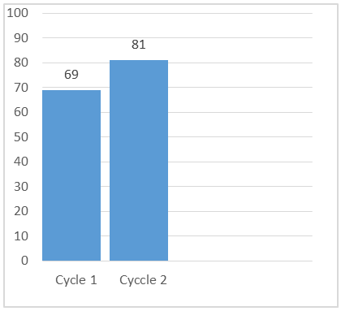

Chart 1. Students Participation in Each Cycle

The researcher reflected on these results and implemented adjustments in cycle 2, leading to an increase in student participation to 81 and an average speaking test score of 80.

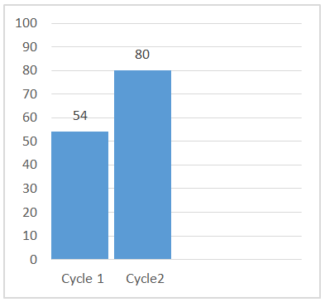

Chart 2. Students Speaking Performance in Each Cycle

This marked improvement met the research objectives, prompting the researcher to conclude the research after the second cycle.

Despite the success, some students still faced challenges with pronunciation. Interviews conducted with six students—representing high, medium, and low scorers—further supported the conclusion that role play effectively increased engagement and improved speaking performance. Overall, the research successfully addressed the initial questions, proving the effectiveness of role play as a method for enhancing student participation and speaking skills in English learning activities.

# CONCLUSION

**Conclusion**

This research identified the challenges students face in learning to speak English, particularly in pronunciation and active participation during class. Many students were hesitant or shy about speaking English, while others demonstrated limited speaking abilities. To address this, the researcher aimed to find an effective technique to engage students and encourage them to use English confidently in class.

The research was conducted over two cycles, each consisting of two meetings, and utilized both qualitative and quantitative data. Qualitative data was gathered through observation checklists, interviews, field notes, and documentation, while quantitative data was obtained through a speaking test.

The implementation of the role-play technique in class XIA at SMA Negeri 1 Kayan Hulu proved to be effective in enhancing students' speaking abilities. Role play not only improved students’ confidence in speaking English but also helped them express characters effectively and interact with their peers in English. This technique made students more enthusiastic, active, and confident during the learning process.

The results showed significant improvement in students' participation and speaking performance. In cycle 1, students' participation averaged a score of 69, while their speaking performance averaged 54. By cycle 2, participation had increased to an average of 81, and speaking performance had improved to an average of 80. These findings indicate that the role-play technique was successful in boosting both participation and speaking skills.

In conclusion, the use of role play effectively addressed students' speaking challenges, enhanced their learning process, and significantly improved their confidence and communication skills in English.

**Suggestions**

Based on the conclusions of this research, the researcher offers several recommendations for teachers, students, and future researchers in this field. English teachers are encouraged to be innovative and creative in designing classroom activities and teaching strategies, as these can significantly impact students' interest and engagement in the learning process.

For students who face challenges with pronunciation or participation, the role-play technique is highly recommended as it effectively enhances communication skills and classroom involvement. This approach prioritizes active student participation, allowing them to improve their speaking abilities while engaging more confidently in the learning process. However, it is essential to ensure that students understand the educational material, and additional support should be provided to those with lower performance. Teachers are advised to take on a guiding role rather than simply delivering instruction.

Finally, future researchers are encouraged to explore the use of role-playing strategies, particularly in teaching speaking. This technique has proven effective in improving students' speaking skills and can be a valuable tool in language education.

# REFERENCES

Adelita, D., & Daulay, S. H. (2023). *Postgraduate students' difficulties and strategies on speaking* (Vol. 5). Sumatra Utara.

Akhter, S., Haidov, R., Rana, A., & Qureshi, A. (2020). EXPLORING THE SIGNIFICANCE OF SPEAKING SKILL FOR EFL . *Palarch's Journal of Archaeology of Egypt/Egyptology* , 17(9). ISSN 1567-214x.

Bahrani, T., & Soltani, R. (2012). How to Teach Speaking Skill? . *Journal of Education and Practice* , ISSN 2222-1735 (Paper) .

Burns, A. (2022). Action Research in English Language Teaching: Contributions and Recent Developments.

Cherry, C. (1956). *On Human Communication A REVIEW, A SURVEY, AND A CRITICISM.* California.

Cohen, L., Manion, L., & Morrison, K. (2018). *Research Methods in Education.* New York: Routledge.

Deneeve, K. M., & Heppner, M. J. (1997). *Role Play Simulations: the assessment of an Active Learning Technique and Comparisons with Traditional Lectures.*

Efron, S. E., & Ravid, R. (2013). *Action Research in Education a Practical Guide.* New York: A Division of Guilford Publications.

Grugeon, E. e. (2012). *Teaching Speaking & Listening in the Primary School.* New York: David Fulton Publishers.

Harmer, J. (2001). *The Practice of English Language Teaching Third Edition.* London: Longman.

Hiebert, E., & Kamil, M. (2005). *Teaching and Learning Vocabulry.* London: LAWRENCE ERLBAUM ASSOCIATES, PUBLISHERS.

Hussain, S. (2017). Teaching Speaking Skills in Communication Classroom. *International Journal of Media, Journalism and Mass Communications (IJMJMC)*, PP 14-21 .

Kay, M. (1979). FUNCTIONAL GRAMMAR . *Xerox Palo Alto Research Center* .

Ladousse, G. P. (1987). *Role Play.* London: Oxford English.

O'Connor, K., Greene, H. C., & Anderson, P. J. (2006). A tool for Improving Teacher Quality and Classroom Practice. *American Educational Research Association*, San Fransisco.

Oppenheimer, D. M. (2008). *Trends in Cognitive Sciences.* USA: Cell Press.

Purnamawati, S., Sofian, & Suhartono, L. (2015). The Use of Role Play in Teaching Speaking.

Saldaria , E., Ariawan, V., & Cahyani, I. (2019). Speaking skill of elementary school students reviewed by gender. *Jurnal Prima Edukasia*, 7 (1), 2019, 20-27.

Tompkins, P. K. (1998). Role Playing/ Simulation. *The internet TESL Journal*.